Skipper CCD Collaboration - Phase II

Project Mandate
Author(s): NOIRLab-ES Detector Group
Marco Bonati, Shane Jacobson, Luis Padilla, Braulio Cancino, Peter Moore
Project Reference Code
Release Version: 1.0
Release Date: 2024-05-16
Distribution: Internal Use

Approvals
Skipper CCD Collaboration - Phase II
Author(s) | Release Date
Marco Bonati | 2024-05-16
Shane Jacobson
Luis Padilla
Braulio Cancino
Peter Moore
Document Owner | Approval Date
Marco Bonati | 2024-05-16
Approved By | Signatures/Stamp
Felipe Daruich NOIRLab Head of Electrical Engineering (sponsor)
Michiel Van Der Hoeven NOIRLab ES Director

Change Record

Release Version | Release Date | Description | Change Owner
1.0 | 2024-05-16 | First draft | Felipe Daruich

Table of Contents

Purpose / Scope of Document 4
Project Definition 4
Project Background 4
Project Objectives 5
Constraints 5
Assumptions 6
Outline Business Case 6
Reasons/Benefits for doing this project 6
Business Option Analysis 7
Project Approach 7
​Recommended Approach 8
Needed Project Resources for completion 9
Project Scope 10
Proposed Project Tolerances 10
Project Baseline (Small Projects only) 11
Deliverables 11
Schedule 11
Resource Plan 12
Appendix A. Applicable Reference Documents - Associated Products 13
Appendix B. List of Acronyms 14
Appendix C. Small format MAS skippers at FermiLab 15

Purpose / Scope of Document
Project mandate to continue with the Skipper CCD collaboration project - Phase II, after successful Phase I, where the technology was proven to work in astronomy applications. Phase I ended successfully after two nights of an observing campaign at the SOAR telescope using the SIFS instrument. The Phase I program is considered a success in that the objective of demonstrating scientific gains through the low noise capabilities of this technology have been met. The demonstration produced the lowest readout noise ever achieved by a CCD in astronomical applications.

Project Definition

Project Background

Current Skipper CCD technology is in use in particle physics laboratories since its successful testing in 2017 at Fermilab and LBNL. This technology provides for very low readout noise of silicon photon / electron detectors being able to achieve readout noises as low as 0.039 e-(1). This extremely low noise presents a very interesting potential for certain astronomical applications where the sky background noise contribution does not dominate. The inherent capability of tuning the desired read noise allows for a wide range of applications while using the possibility of minimizing the read time by choosing which readout areas should have low noise (multiple samples / regions of interest). In addition, considering that these are intrinsically quantum devices makes them very interesting for future Quantum applications too. These are the devices of choice for DESI-2.0 and SPEC-S5, and this pushed forward a strong ongoing development (a collaboration between NOIRLab, Fermilab, U.Chicago, LBNL and LNA) to test Skipper CCDs on the sky.

The first phase of this collaboration was to deploy four Skipper CCD devices in a focal plane for the SOAR Integral Field Spectrograph (SIFS) which is a working instrument at the Southern Astrophysical Research telescope (SOAR). The low background and high resolution of this instrument makes this instrument a very good candidate for the first testing of the skippers' performance on the sky.
The Skipper Dewar and associated controller and electronics were installed on SIFS during the last week of March. On March 31st the collaboration achieved the first light verification of the Skipper devices, achieving the target readout noise figure of less than 0.7 e- using 50 non-destructive samples. Further verification using photon counting mode achieved a noise value of 0.22 e- using 250 non-destructive samples. Further results were achieved on the second night of observing (April 9th) where the Fermilab observers were able to observe the quasar lines from their target of choice (the observational objective was to see very faint lines from a quasar for an axion search program). For details on Phase I please see papers on Appendix A.

The Phase 1 program is considered a success in that the objective of demonstrating scientific gains through the low noise capabilities of this technology have been met. The demonstration produced the lowest readout noise ever achieved by a CCD in astronomical applications.
During Phase I, Fermilab packaged and shipped us several skipper devices, as well as the electronics to read them (LTA). On the NOIRLab side, the engineering and coordination with external and internal teams was done by the CTIO detectors team. The manufacturing and gathering of all the parts to build the Dewar was done in the MSO machine shop in Tucson. The designing of new parts of the Dewar (and adaptation of some) was done at MSO-S and LNA, while the actual machining was done at the MSO machine shop in La Serena. The design of the internal electronics, cabling, etc, was done at MSO-S.. The metrology of the focal plane once all the detectors were installed was done at Gemini South using a profilometer provided by Gemini North. During the installation at SOAR we verified the design and building of the parts, as well as the metrology was so well done that we did not need to make any change in the optical alignment (we took the old Dewar and put the new one, and it all worked at first go). Final integration and installation was done by technicians from SOAR (electronics and mechanics), who also provided onsite support during the observing campaign.
This was a huge successful collaboration across all NOIRLab centers!.

Project Objectives
The drawback of Skipper technology is the readout time, as the readout time multiplies by the number of samples. In order to minimize this impact, the low-noise (multi-sampling) was done in selected areas of interest, leaving the rest of the image with a single sample noise of approx. 3.8e- rms. To achieve a noise figure of 0.5 e- rms on the complete detector area where the full dispersion range is available requires fifty samples with a readout time of approximately 25 minutes. Since we also wanted to demonstrate the ability to do photon-counting, deeper sampling (250) was carried out in selected small areas (ROIs) around particular fibers of interest. While we were able to achieve 0.22 e- -and the ability to photon count was demonstrated-, the readout time was approximately 20 minutes. This long readout time is the limitation we plan to address in Phase II of this collaboration.
The Phase II collaboration’s objective is to verify and characterize the performance of the newer generation of Skipper CCD devices, which have multiple sensing nodes, allowing for multi-sampling in a single read. The potential benefit of these devices is immense, as would allow sub-electron noise in normal read times for a CCD (20-40 seconds). Besides the potential for future instruments (DESI-2.0, SPEC-S5), this also has the benefit of providing a very interesting upgrade path for some spectrographic instruments in use at the AURA observatories. These devices are called Multi-Amplifier Sensing (MAS) skippers, and Fermilab is also interested in testing these devices on the sky on the context of SPEC-S5, so Phase II will also be a collaborative effort.
Small-format MAS devices (512x1024 pixels) already exist. In particular, they have already packaged some of these devices in picture-frame packages, and they are currently being tested at Fermilab. These are the ones we intend to test by adapting an old “golden” CTIO Dewar to be used on a small telescope, like the 0.9m, that is already fully compatible with these Dewars, as can be seen in Appendix C

Constraints
The only identifiable risk so far uncovered is if the sample MAS devices in their picture frame mounting fixtures do not fit inside the golden Dewar with the preamplifier boards. In this case the planned effort will be larger since we would need to also design an internal cabling or flex circuit to connect the Skipper detector to the preamp and the preamp to the hermetic.

Assumptions

- Fermilab group working under a grant for SPECS-5 (see Appendix A) will provide samples of 512 x 1024 pixels devices with 8 and 16 sensing nodes packaged in picture frames with anti-reflective coating. The PI of this program has already expressed great interest in testing these devices on the sky, as a pre-test for the larger format ones. See under Recommended Approach
- After testing these small devices in our lab, an existing “Golden Dewar” can be modified to install one of the larger format devices provided by Fermilab. This takes the advantage of the easy installation of these Dewar, which are already mechanically compatible with NOIRLab telescopes like the 0.9 m.
- A small telescope (preferably the CTIO 0.9 m telescope) can be made available for on-sky testing

Outline Business Case

Reasons/Benefits for doing this project
- NOIRLab mission is: ”Enabling and sharing breakthrough discoveries in astronomy and astrophysics with state-of-the-art ground-based observatories, data products, and services for a diverse and inclusive community ”. Detector’s technology is moving in this direction, and being part of this development allows us to have state-of-the-art ground-based observatories. Also, note that the ITDC community survey found that “detectors and detector controllers” was the main technology that the community was interested in. This will be a very important detector contribution to the community.

- MAS Skippers CCD can potentially be installed on several instruments across NOIR Lab maximizing their capabilities and improving their science productivity.

- The Phase II experiment will provide the necessary on-sky validation towards achieving a large format detector using the Skipper MAS technology. This will demonstrate technology for DESI-2.0 and SPEC-S5 spectrographs, leaving NOIRLab in a strong position with regard to this novel technology.
- The on-sky validation mentioned above would also imply the potential for some spectrographs in use at AURA observatories. Example spectrographic instruments for potential upgrade using very low noise Skipper MAS detectors are SIFS, CHIRON, MAROON-X, GRACES, GMOS, and GHOST.

Business Option Analysis

Option | Analysis
Option 1 –  Do nothing | Advantages, Benefits: | - None
Option 1 –  Do nothing | Disadvantages, cost, risks: | - Lose the opportunity to be in the forefront of technology (example, SPEC-S5) and retrofit NOIRLab instruments to increase productivity.
Option 2 –  Skipper CCD - Phase II | Advantages, Benefits: | - On-sky validation towards larger scale detectors that can be used in NOIRLab instruments as well as future, massive instruments like STAGE-S5.  - Increase science productivity of NOIRLab instruments.  - Leave NOIRLab as one of the world-leaders in detector technology  - The project is exactly aligned with the mission goal of “Enabling and sharing breakthrough discoveries in astronomy and astrophysics with state-of-the-art ground-based observatories”
Option 2 –  Skipper CCD - Phase II | Disadvantages, cost, risks: | - None

Project Approach
Phase I of the Skipper project is completed after successful first on-sky testing on SOAR telescope. There are several more scheduled observations using the Skipper device because of the successful performance of these devices during Phase I (there were two in May, another upcoming in July) These are to complete the science program on SIFS for the PI. In addition, there are ongoing discussions about trying the very same Skipper Dewar on CHIRON given that it would also benefit from the low noise and the possibility of photon counting. The CHIRON Dewar is mechanically identical, so it would be a relatively simple matter of removing the CHRON Dewar and installing the Skipper Dewar. This configuration will be an interesting demonstration for NASA who are already interested in the Skipper CCD technology for spectroscopic biosignature searches in exoplanets among other objectives of their science program.
Now, in order to meet the Phase II collaboration objective, we require the implementation of a Skipper MAS device inside a “Golden Dewar'' (i.e. Skipper MAS picture frame device with a JFET preamplifier board and hermetic connector), tested on the laboratory and then deployed on a small telescope at CTIO.

​Recommended Approach

Fermilab in partnership with LBNL are already producing what are called Multi-Amplifier Sensing Skipper (MAS) which serialize the multi-sampling algorithm on the detector itself. These devices are constructed with serial multiple sensing nodes and output amplifiers in the CCD readout register. Each pixel charge packet is transported across these multiple amplifiers, sensed, then sampled, and averaged, thus reducing the readout time by the number of available serial sample amplifiers. The effective noise reduction compared to a single pixel read is then equivalent to the square root of the number of sensing amplifiers. This means, for example, that on the SIFS Skipper Dewar that has a single sample noise 4e-, an equivalent MAS device with 16 sensing nodes would have sub-electron read noise on a single read with a readout time equivalent to a single read. Thus decreasing the readout time from twenty minutes to approximately one minute without any further optimization.
The ideal detector format for both the SIFS and CHIRON applications would be a single 4k x 4k, 15 um pixel MAS device with at least 16 outputs per quadrant (64 amplifier channels total). Such a device is in the process of being designed at LBNL and will probably be ready for packaging by the end of 2025 (so this may indeed come as Phase III), and in any case we currently do not have the controller electronics to handle 64 outputs (unless we consider using “old” electronics like a MONSOON). However, smaller versions of MAS detectors with different formats and different numbers of sensing nodes (8,16 and 32) of MAS devices do already exist and are being tested in the laboratory at Fermilab. Most of these detectors are to be used for dark matter and low energy neutrino searches, so they are not backside processed, coated, or packaged in a way that could be useful for astronomy. However, there are two groups working with devices whose ultimate goal is to be used in astronomy. One of them is a group at Fermilab working under a grant from the Office of High Energy Physics called “Demonstrating enabling technologies for a spectroscopy instrument for the next cosmic survey” (See Appendix A), aimed mostly at MAS skippers and fiber positioners for SPEC-S5. They currently have a few 512 x 1024 pixels devices with 16 sensing nodes packaged in picture frames with anti-reflective coating. The PI of this program has already expressed great interest in testing these devices on the sky, as a pre-test for the larger format ones.
Given the small format of these devices, they would not be very scientifically useful on the SIFS or CHIRON instruments. However, they can be deployed on a smaller telescope and be used as imagers to verify how they perform on the sky and how fast they can really be read out whilst preserving the low readout noise. In order to fully characterize the low noise capability, we plan to use a very narrow band filter to limit the background. Further testing of other characteristics such as full well and linearity will also be tested as the technology matures.
We have several smaller Dewars available for these smaller format devices (“Golden Dewars” originally from Arcon/ CTIO times) and we already have the software and hardware to read 16 channel devices (the same LTA controller electronics we used to read out the devices we describe in the Phase I collaboration). We see an opportunity to install one of these small devices in a modified Golden Dewar (if possible, using the same internal electronics the Fermilab is using in their lab) and deploy the system in one of the small telescopes at CTIO. These Dewars are already mechanically compatible with, for example, the 0.9 mtr telescope on Tololo and the installation will not require much effort. Another advantage of the 0.9m is that it already has a fully functional filter wheel that could be used to install the narrowband filter mentioned before.

Needed Project Resources for completion

Needed Project Resources for completion
Specific Competencies /Skills /People needed | - Project Manager (part time)  - Electronics Engineer: Detector specialist.  - Electronics Engineer: Electronics designer.  - Electronics Technician: Electronics assemblies and wiring.  - Mechanical Engineer: Mechanical interfaces design.  - Mechanical Technicians: Mechanical assembly, mechanical installation at telescope.  - Instrument Maker: For parts fabrication in the machine shop.  - Night Assistant or astronomer: Telescope and instrument operation during testing.  - Astronomer: For data reduction and analysis.
Internal labor effort (FTE) until completion | - Electronics Engineer: 174 hours  - Electronics Technician: 234 hours  - Mechanical Engineer: 168 hours  - Mechanical Technician: 60 hours  - Instrument Maker: 64 hours  - Night Assistant: 36 hours  - Astronomer: 40 hours
Non-labor Cost (USD) | Connectors, cables and other materials: $2K
Project Duration (Months) | Design: 5 months  Integration: 4 months  Testing: 1 month  Total: 10 months
Impact on Telescope Operations | No impact on telescope operation expected. Plan considers using the 0.9 m telescope operated by SMARTS that is currently not in use.
Contract Complexity | No contract required
Track Record | Phase I, successfully completed and substantially more complex than Phase II.
Infrastructure | Existing lab, machine shop and telescope
Technology/ Standards | Existing “Golden Dewars” originally and software and hardware to read 16 channel devices (the same LTA controller electronics we used to read out the devices described in Phase I). Software to run the 0.9m also existent (scripts, TCS, GUI, filters, etc)
Recurring Costs | None

Project Scope
The scope of this project is to continue with the development and testing of the skipper CCD technology, this time aiming to reduce the readout time to make it suitable for astronomy applications. Below is a detailed list of reasons we propose to move forward with Phase II:
- Phase I demonstrated this technology could make a huge impact in astronomy due to the low noise achieved in on-sky observations. Actually, the lowest read out noise ever achieved in astronomical observations with a CCD.
- A downside for astronomical usages is the long read out time. However, Fermilab in partnership with LBNL, are already producing what are called “Multi-Amplifier Sensing Skipper” (MAS), which serialize the multi-sampling algorithm on the detector itself , thus reducing the read out time considerably (when read by the appropriate multichannel electronics amplifier)
- Phase II will test these new MAS devices on-sky, expecting to achieve the same read noise than Phase I at a small fraction of the read out time. This will enable the MAS technology on the sky, opening the door for developing and testing future, big format devices that may have a real impact on current and future instrumentation.
- If successful, this development will help to boost NOIRLab as a leading institution in detector development, and also enable the possibility to upgrade some instruments to the forefront of technology and science productivity. It will also validate future, massive instruments like SPEC-S5, which may have a direct impact in NOIRLab’s future instrumentation.

Proposed Project Tolerances

Project Area | Baseline value | Proposed Project Tolerance
Time (+/- time on target completion dates) | 10 months | - 2 months contingency
Costs (+/- amounts of planned budget)
Scope (permitted scope variations) | Demonstrate and characterize the small-format Skipper MAS device on sky with low read noise and normal readout time | Requirement is to achieve <1e- rms with < 60 second read time.  Goal is to achieve 0.7e- rms with < 30 second read time.
Risk (permitted aggregate/individual threat value)
Quality (permitted quality variations within a range)
Benefits (permitted benefit variations within a range)

Whenever the tolerance for one of these baseline values is exceeded (or forecasted to be exceeded), the Project Advisory Board (PAB) should be alerted of the exception.

Project Baseline (Small Projects only)

Deliverables
As this project is a development and testing, there are no deliverables other than the test results. However, the scientific and engineering papers produced may be used as reference material for future developments, not just inside NOIRLab, but worldwide, raising NOIRLab as a world-class institution in technology development. In particular, they will be especially useful for advancing the Fermilab SPEC-S5 grant work mentioned in Appendix A, which may have a direct impact on NOIRLab’s future instrumentation. It is noteworthy that Phase I yielded numerous engineering and scientific publications from NOIRLab and Fermi/U.Chicago. In Appendix A you can download the final engineering paper, that contains Phase I development and result details (SPIE, Telescope and Instrumentation, 2024)

Schedule
- Prepare “Golden Dewar” (clean, leak check, retrofit with modern vacuum gauge, etc)
- Design a mount/plate to fit the detector and preamp inside the prepared “Golden Dewar”.
- Design/manufacture adaptor from internal cabling to hermetic connector of choice
- Manufacture a cable from the Dewar plate/connector to our current LTA box.
- Mount electronic component on the current (i.e. Phase I) preamp board, or design/manufacture a new one, if needed.
- Design/manufacture a mechanical mount for the LTA box (controller) on the Dewar.
- Receive the test Skipper MAS device(s) and test in our Lab.
- Design mechanical adaptor for the Dewar (in case required), plus some tip/tilt/focus mechanism.
- Install auxiliary electronics (filter wheel control, shutter, etc.).
- Install control and acquisition software.
- Carry out on-sky testing and verification (data analysis).
- Write end of project report, device characterization report and possibly a journal paper.

Resource Plan
Labor plan
Labor Resources (Hours) | Oct | Nov | Dic | Jan | Feb | Mar | Apr | May | Jun | Jul | Aug | Sep | Total
Detector Engineer (Marco Bonati) |  | 36 | 36 |  |  | 36 |  | 12 | 54 |  |  |  | 174
Detector and electronics engineer  (Luis Padilla) |  | 12 | 12 |  |  | 12 |  | 12 |  |  |  |  | 48
Electronic Engineer (Braulio Cancino) |  | 16 | 16 | 16 |  |  |  |  |  |  |  |  | 32
Electronics Technician (Victor Aguirre)) |  | 60 | 60 | 54 |  |  |  |  | 60 |  |  |  | 234
Mechanical Engineer (Camilo Aviles) | 60 |  |  |  | 36 |  | 60 | 12 |  |  |  |  | 168
Mechanical Technician (Rossano Rivera) | 60 |  |  |  |  |  |  |  |  |  |  |  | 60
Instrument Maker (Name here) | 16 |  |  |  | 12 |  | 36 |  |  |  |  |  | 64
Night Assistant (Name here) |  |  |  |  |  |  |  |  |  | 36 |  |  | 36
Astronomer (Cesar Briceno) |  |  |  |  |  |  |  |  |  | 60 |  |  | 60
 | Total Hours for FY25: |  |  |  |  |  | 876 (0.5)

Non-labor plan
Non-labor plan | FY25
Non-labor Costs (K USD - committed) | Oct | Nov | Dic | Jan | Feb | Mar | Apr | May | Jun | Jul | Total(k$)
Connectors, cables and materials |  | 2000 |  |  |  |  |  |  |  |  | 2000
 | Total Non-Labor FY25 $: |  |  |  |  |  | 2000
 | Risk Budget: |  |  |  |  |  | [USD/FTE; it can be +/- 5%]
 | Change Budget: |  |  |  |  |  | [USD/FTE; it can be +/- 5%]

Appendix A. Applicable Reference Documents - Associated Products

Document Number / Link / Identifiers | Document Title
NSF 21-107 (December 2021) | NSF Research Infrastructure Guide
arXiv:1706.00028 | Single-electron and single-photon sensitivity with a silicon Skipper CCD.
SPIE_Proceedings__Skipper_on_SOAR.pdf | Skipper CCD Mosaic on the SOAR Integral Field Spectrograph
FY-2023-DOE-SC-Early-Career-Research-Program-Abstr_240529_193350-pages-2.pdf | Demonstrating enabling technologies for a spectroscopy instrument for the next cosmic survey (abstract)
arXiv:2311.00813 | Characterization and Optimization of Skipper CCDs for the SOAR Integral Field Spectrograph.
arxiv:1709.06660 | Space technology for directly imaging and characterizing exo-earths.
arxiv:2301.10891 | Infrared photon-number resolving imager using a skipper CCD.

Appendix B. List of Acronyms
- CCD : Charge Coupled Device
- CTIO : Cerro Tololo Inter-american Observatory
- DESI : Dark Energy Spectrographic Instrument
- JFET : Junction Field Effect Transistor
- LBNL : Lawrence Berkeley National Laboratory
- LNA : Laboratorio Nacional de Astrofisica (Brasil)
- LTA : Low Threshold Acquisition (controller)
- MAS : Multi-Amplifier Sensing
- NASA : National Aeronautics and Space Agency
- PI : Principle Investigator
- WP : Work Package
- SIFS : SOAR Integral Field Spectrograph
- SOAR : Southern Astrophysical Research (Telescope)
- SPEC-S5 : Stage-5 Spectroscopic Experiment

Appendix C. Small format MAS skippers at FermiLab

Small format MAS skippers are being tested at Fermilab in their own testing system (”Cubes”), but they have also verified that the picture frames and electronics do fit in the Golden Dewar, as can be seen in the images below.

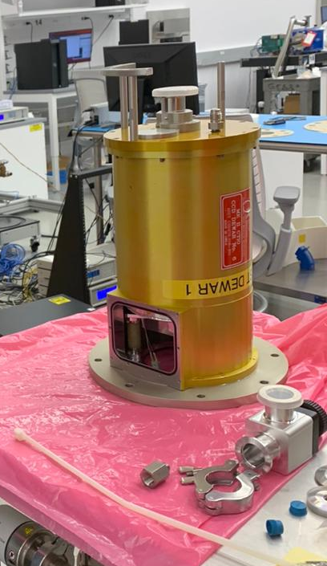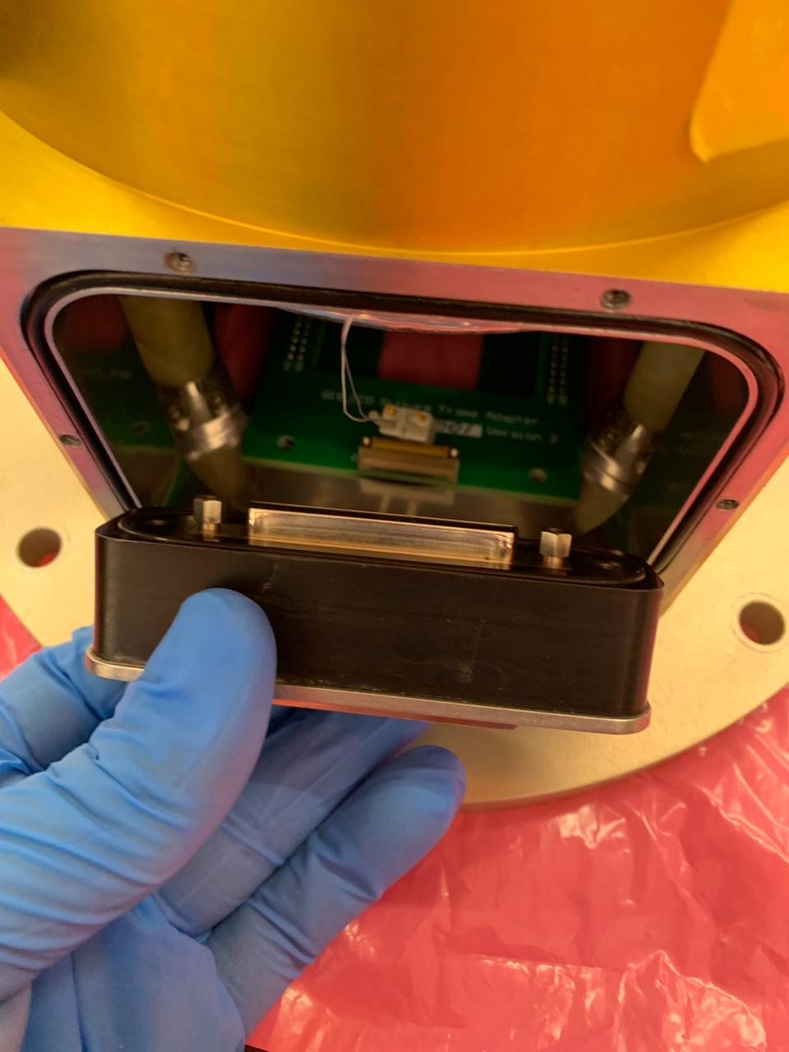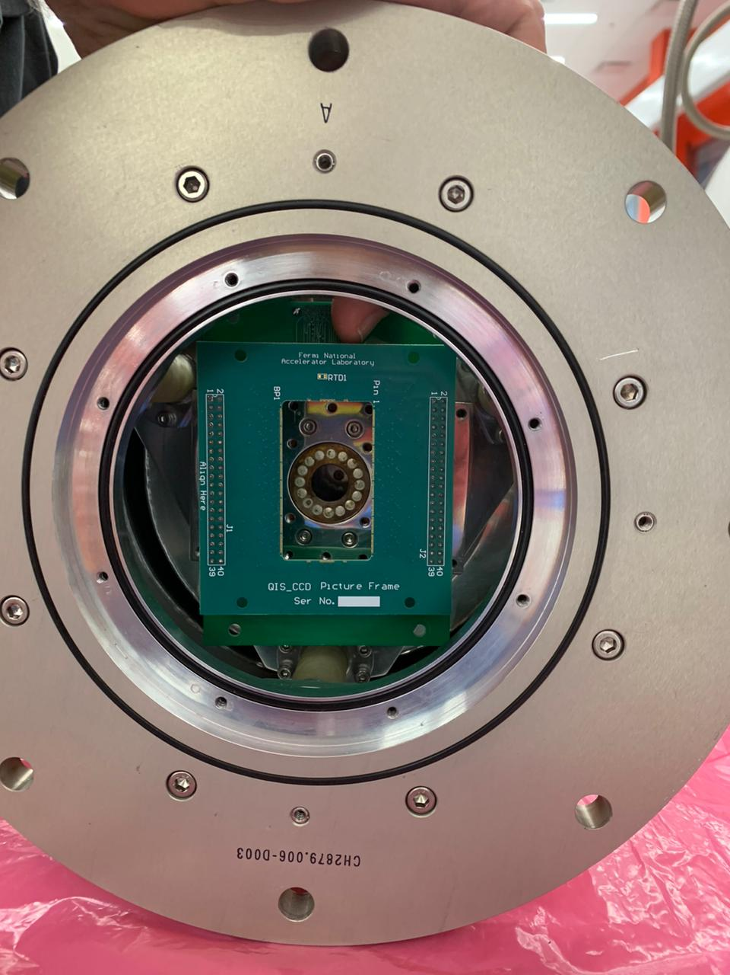

Golden Dewar at Fermilab. Left: Golden Dewar overview, ready to be disassembled. Center: Matching of a DB50 feedthrough connector for the MASS skipper. Right: An empty picture frame used for the MAS skippers inside the Golden Dewar, verifying that they do fit without problems.

We will proceed to modify an identical Dewar here to receive the parts and install them to test in the laboratory first, and in the telescope afterward.

